3 6 9 a i . B i z

KRA / KPI

  - Client Guide
Send in your requirements, approve who works on them, and sign off finished work.

About Your Client Portal
This app is how you and your development team stay on the same page. You use it to do three things:
▪ Send in work — new requirements, changes to existing work, and bugs you have found.
▪ Approve who does it — when the team assigns someone to your task, you get to agree before they begin.
▪ Sign off what is delivered — you confirm the work is done and works, and only then can it be invoiced.
You only ever see your own work. Everything is scoped to your account.
IMPORTANT Nothing is billed until you sign it off. Approving a developer at the start only lets them begin working — it is not approval to invoice. The invoice question is settled at the end, by your sign-off.

How Your Work Flows
▪ You upload a requirement, an update or a bug report
▪ The team turns it into tasks and assigns a developer
▪ You approve or reject the assignment
▪ The developer does the work
▪ An admin checks it, then sends it to you
▪ You sign it off — and only now can it appear on an invoice

PART 1 GETTING INTO THE APP

Step 1 Open the App
Open the KRA KPI app on your phone. After a short animation you reach a welcome card. Tap Tap to Enter Login Page.
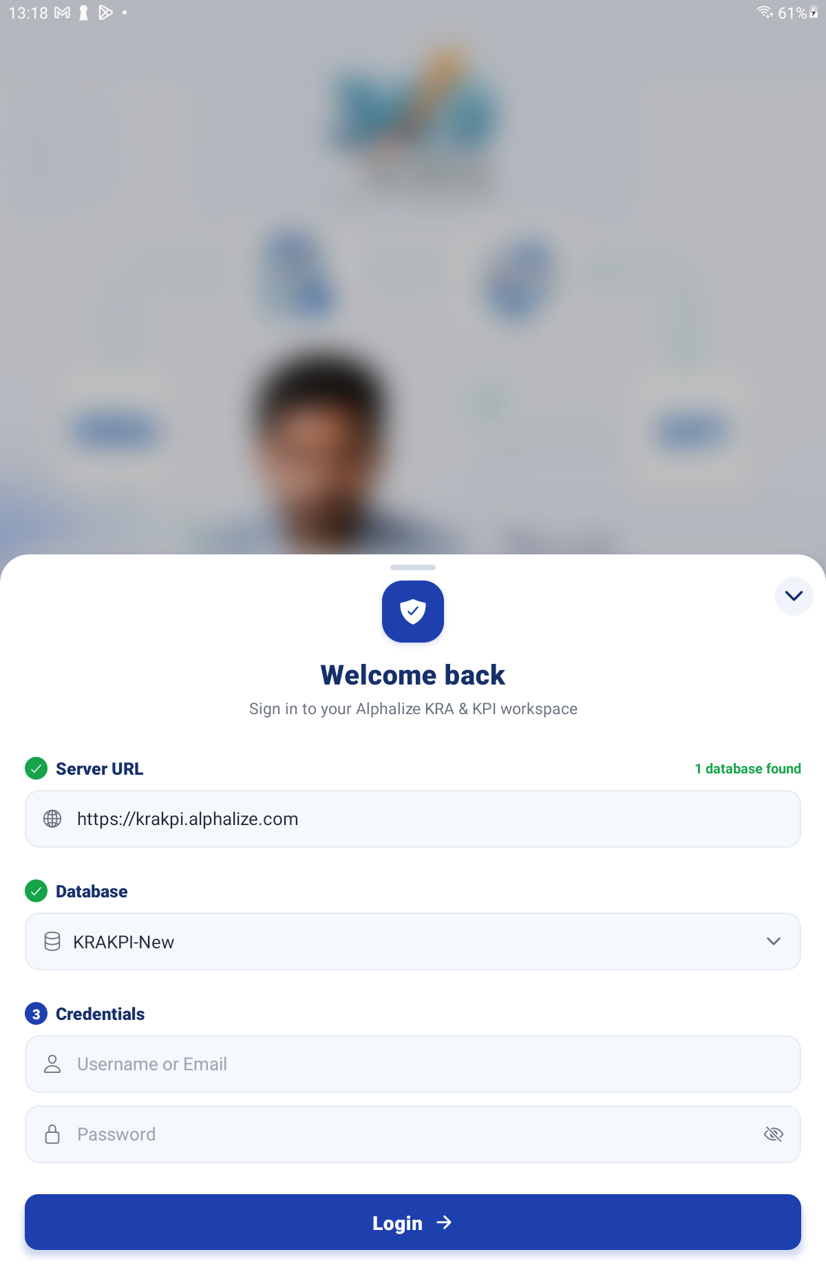
The welcome screen with the “Tap to Enter Login Page” button

Step 2 Enter Your Mobile Number
Your country dial code is already filled in. Type the rest of your mobile number and tap Continue. Use the number your account was set up with.
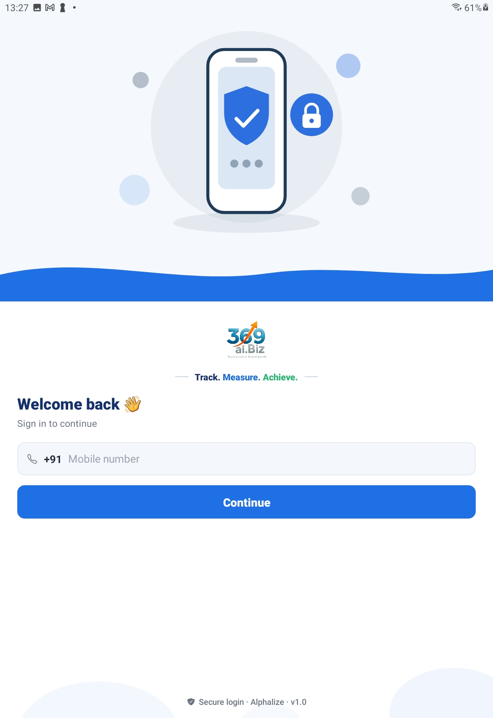
Sign-in screen — mobile number field and the Continue button

Step 3 Enter Your Password
Type your password and tap Log In.
The very first time, your password is 1111. The app shows a red warning saying so. Please change it straight away — tap Forgot password?.

Step 4 Set Your Own Password
A 4-digit code is sent to you on WhatsApp. Type the code, type your new password twice, then tap Verify & Set Password. If the code does not arrive, tap Resend code.
You can change your password any time later from the Profile tab, the same way.

PART 2 YOUR HOME SCREEN

Step 5 Find Your Way Around
The Home screen greets you by name. Under the greeting, Your Tasks shows four counters. Tap any of them to open your Requests list, already filtered:
Counter | What it counts
Awaiting Client | Work finished and waiting for you to sign off. Start here.
In Progress | Being worked on right now.
On Hold | Paused for some reason.
Completed | Finished and signed off.

You have six tiles:
Tile | What it is for
Upload Requirements | Send in new work you want built.
Upload Updates | Send in changes to work that already exists.
Upload Bug Reports | Report something that is broken.
Requests | See all your tasks, approve developers, and sign off finished work.
Invoices | View your invoices and tell us when you have paid.
User Manual | This guide, and anything else shared with you.

The ☰ menu at the top left opens the full menu; the bell at the top right opens your notifications.
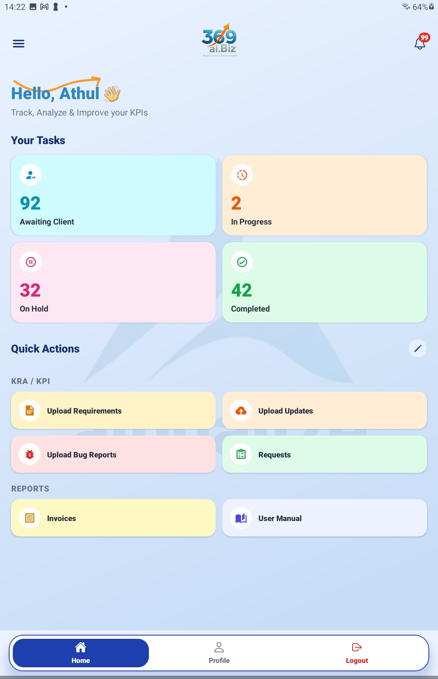
Client Home screen — the four counters and the six tiles

PART 3 SENDING IN WORK
All three upload tiles work identically — only the kind of work differs, and each gets its own reference number:
Tile | Ref | Use it for
Upload Requirements | REQ | Something new you want built.
Upload Updates | UPT | A change or amendment to existing work.
Upload Bug Reports | BUG | Something that is not working correctly.

Step 6 Check the Destination
Section 1 Destination is filled in for you — your project is already selected and cannot be changed, because you only have the one. You may optionally type a Version (for example v1.0) to group this batch of work.
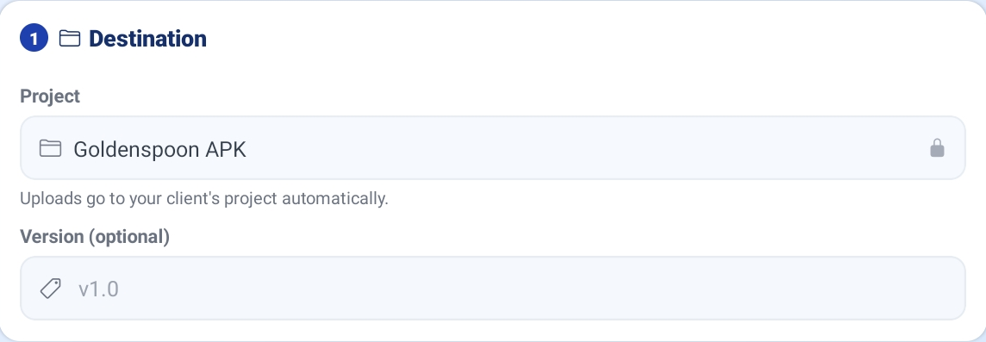
Section 1 Destination — your project shown read-only, with the Version box

Step 7 Add Your Content
Section 2 Source & Bulk Import gives you three ways to get your work in. Use whichever suits you:
▪ Paste text — paste your notes into the box marked “Paste requirement / update / bug text…”. The app reads it and suggests a list of tasks.
▪ Import a spreadsheet — tap Choose file and pick an Excel (.xlsx / .xls) or CSV file. If you pick anything else the app tells you: “Please choose an Excel (.xlsx/.xls) or CSV (.csv) file.”
▪ Download Blank Template — get a correctly formatted spreadsheet to fill in first. This is the easiest route for a long list.
TIP Pasting plain text is the quickest way to raise a handful of items. For a big batch, download the blank template, fill it in on a computer, and import it.

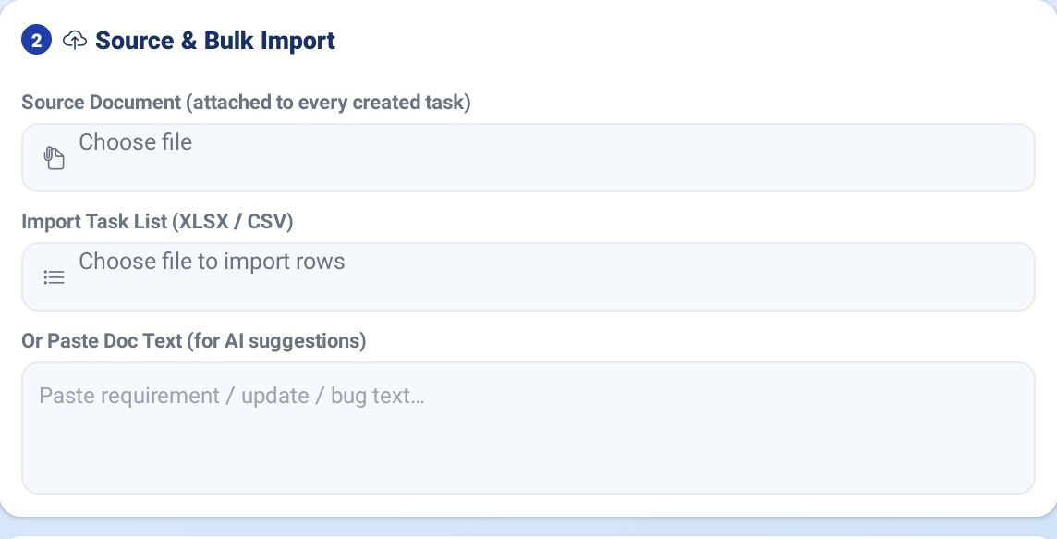
Section 2 Source & Bulk Import — the paste box, Choose file and Download Blank Template

Step 8 Check and Edit the Task Rows
Section 3 lists the tasks that will be created. Every row can be edited, and you can add your own with Add Row. For each row you can set:
Field | What to put in it
Task name | A short, clear description of the one thing to be done.
Ref ID | Filled in for you (REQ-001, UPT-001, BUG-001…). You can override it.
Linked Req | If this is an update or a bug against an earlier requirement, point at it here.
Hours / Minutes | How long you expect it to take, if you have a view.
Priority | Regular, Important or Urgent.

Section 4 Defaults for new rows lets you set the hours, minutes and priority that every new row starts with — handy when you are adding many similar items.
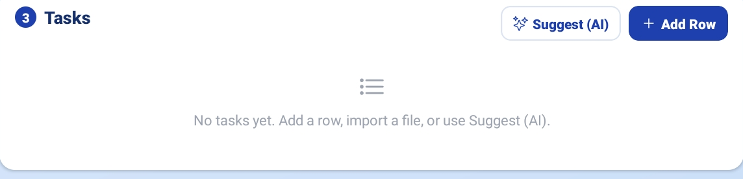
Section 3 — the editable task rows with Add Row

Step 9 Attach Screenshots or Files
Use Add attachment for documents, or Add photos / video for screen recordings and screenshots. This is especially useful for bug reports.
The app asks Why are you attaching this? — type a short reason, and pick which task it belongs to. Both are required, so the team knows what they are looking at.
TIP For a bug, a short screen recording showing the problem is worth several paragraphs of description.

Step 10 Create the Tasks
When the rows look right, tap Create All Tasks. The app confirms how many were created.
If any row fails, it is listed and a Retry failed button appears — tap it to re-send only the ones that did not go through. Reset clears the form and starts again.
The Create All Tasks button and the confirmation after tasks are created

PART 4 APPROVING WHO DOES THE WORK

Step 11 Open Requests
Tap Requests. Anything needing you is pulled to the top in two sections:
▪ ✋ Approval needed — a developer has been assigned and is waiting on your go-ahead.
▪ ⚠ Awaiting your sign-off — work that is finished and needs you to confirm it.
Below those sits your full task list.
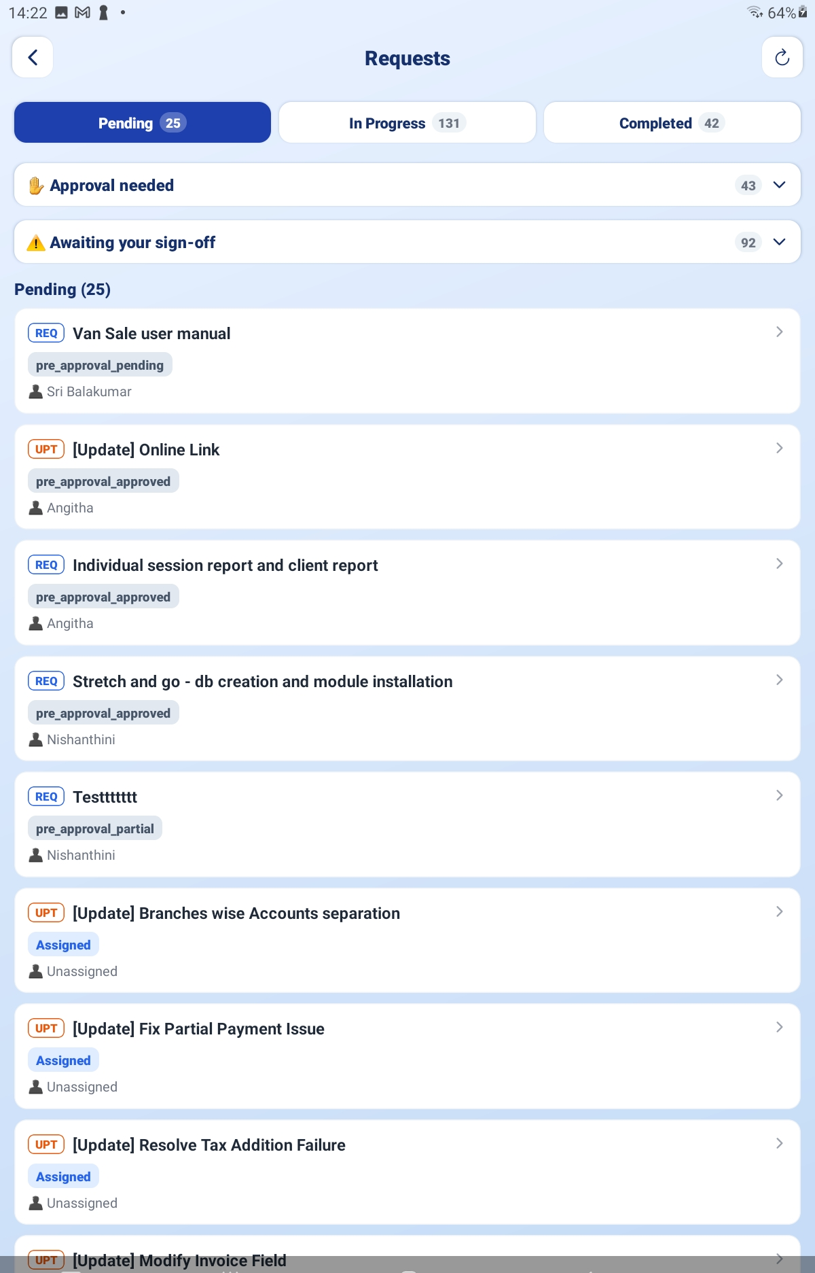
Requests screen — the “Approval needed” and “Awaiting your sign-off” sections

Step 12 Approve or Reject the Developer
Each card under Approval needed shows the task and who has been assigned to it, with a countdown.
▪ Tap Approve if you are happy. You will see “Approved — the developer can start.”
▪ Tap Reject if you are not, and choose a reason.
Reason | Use it when
🔁 Want a different developer | You would rather someone else did this.
📝 Task details are wrong | The task has been written up incorrectly.
🚫 Not needed anymore | You no longer want this done.
✍ Other | Anything else. You must type an explanation — the team cannot act on a blank reason.

After rejecting you will see “Rejected — sent back to the team.”

Step 13 Stop the Clock with Hold
Not ready to decide? Tap Hold. The countdown stops and nothing auto-approves while it is held. Approve and Reject still work at any time. Tap Resume to restart the countdown.
IMPORTANT If you do nothing, the approval releases on its own when the countdown runs out, so your work is never stuck waiting on us. That is only permission to start work — it is never permission to invoice. You still sign off at the end, and that is what makes a task billable.

PART 5 SIGNING OFF FINISHED WORK

Step 14 Open the Sign-off
When work is delivered it appears under ⚠ Awaiting your sign-off. Review it, then tap Sign off this task.

Step 15 Confirm and Sign
The sign-off panel asks you to confirm three things. Tick each one:
▪ The work was delivered to me
▪ I have checked it and it works
▪ I'm authorized to approve this
Then under Type your name to sign, type your full name and submit.
The app notes: “This records your digital approval and generates the completion certificate.”
IMPORTANT Only tick these if they are true. Your sign-off is what turns the task Completed and makes it billable. If the work is not right, do not sign — contact your coordinator and it will be sent back to the team.

PART 6 TRACKING YOUR REQUESTS

Step 16 Read the Status Labels
Every task in your Requests list carries a status. Here is what each one means and whether you need to do anything:
Status | What it means | Your move
Assigned | Logged and given to someone, not started yet. | Nothing.
Urgent | Queued as urgent, not started yet. | Nothing.
Important | Queued as important, not started yet. | Nothing.
Regular | Queued as normal priority, not started yet. | Nothing.
In Progress | Being worked on right now. | Nothing.
On Hold | Paused — a blocker, or waiting on something. | Ask if it has been a while.
Verifying | The developer has finished; an admin is checking it. | Nothing.
Changes Requested | It was sent back to the developer for rework. | Nothing.
Awaiting You | Delivered and waiting for your sign-off. | Sign it off.
Completed | Signed off and closed. | Nothing.

If you have not raised anything yet, the screen simply says “No tasks yet for your client.” Pull down on the list at any time to refresh it.

PART 7 YOUR INVOICES

Step 17 Open Invoices
Tap Invoices. You see only your own invoices, and only once they have been issued to you — drafts are never shown. Filter with the chips at the top:
Chip | Shows
All | Every invoice issued to you.
Payment Due | Invoices still to be paid.
Paid | Invoices settled.

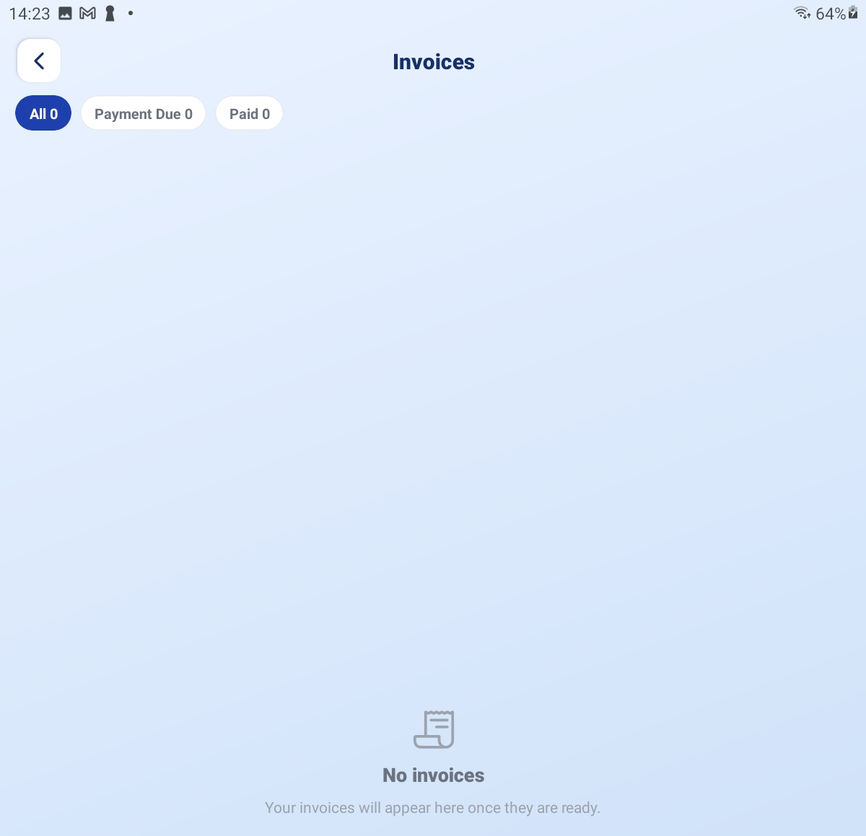
The Invoices list with the All / Payment Due / Paid chips

Step 18 Open One and Check It
Tap an invoice to see its lines. Each line is a task you signed off, grouped by type — Requirements, Updates / Amendments and Bug Fixes. Any agreed correction appears as an ADJUSTMENT line.
Use PDF to save a copy, or Share to send it on to your accounts team.

Step 19 Tell Us You Have Paid
Once you have made payment, mark the invoice as paid in the app. This notifies the team straight away, so nobody chases you for money you have already sent.

PART 8 NOTIFICATIONS AND YOUR PROFILE

Notifications
Tap the bell on Home. Three tabs sort everything:
▪ All — everything.
▪ Unread — what you have not opened yet.
▪ Action needed — the ones waiting on you. Check this one first.
Items are grouped into Today, Yesterday and Earlier, and anything critical carries a red URGENT badge. Tap a notification to jump to the task or invoice it is about. Mark all read clears the badge.
You will be notified when a task needs your approval, when work is ready for your sign-off, and when an invoice is issued to you.
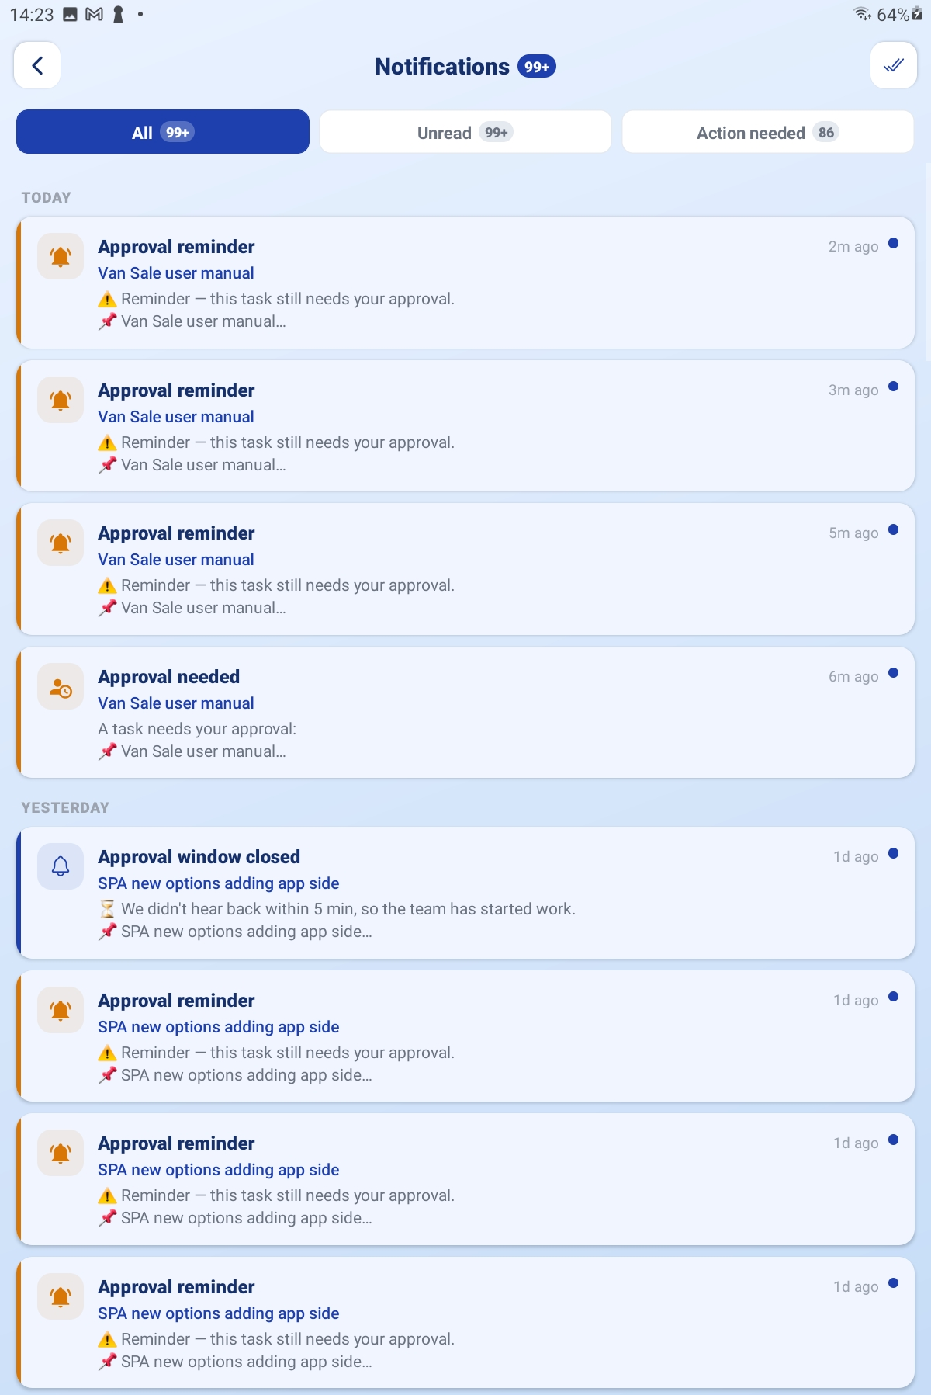
Notifications — the All / Unread / Action needed tabs

Profile
Tap Profile at the bottom of the screen to set your photo, check whether you are Connected, change your password with Forgot Password, or Log Out. Your role badge here reads Client.
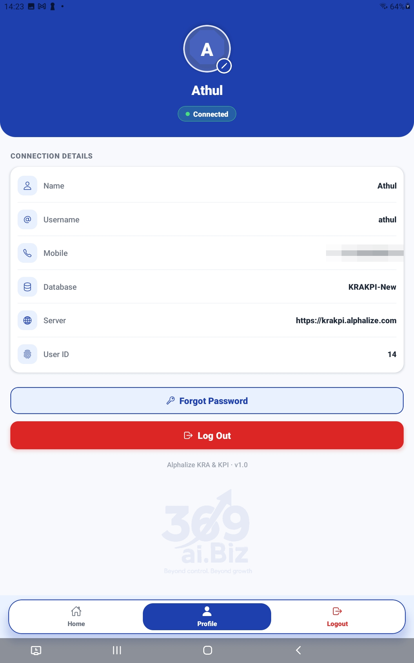
The Profile tab — avatar, Client role badge and the buttons

QUICK REFERENCE

Which Screen, When
Screen | Go there when
Upload Requirements | You want something new built.
Upload Updates | You want a change to something that already exists.
Upload Bug Reports | Something is broken.
Requests → Approval needed | You have been asked to approve a developer.
Requests → Awaiting your sign-off | Work has been delivered and needs confirming.
Requests (main list) | You want to know where something has got to.
Invoices | You want to check or pay a bill.
Notifications (bell) | You want to see everything waiting on you in one place.

Things to Remember
▪ Your sign-off is the only thing that makes work billable. Auto-approval at the start never bills you for anything.
▪ Check the Action needed tab on your notifications — it is the shortest list of things only you can do.
▪ Put one item per task row. Two requirements in one row become one task and are harder to track.
▪ For bugs, attach a screenshot or a short screen recording. It saves a round of questions.
▪ Use Hold if you need time to think about an assignment — it stops the countdown.
▪ Rejecting with Other requires an explanation. Be specific and the fix comes back faster.
▪ If a list looks out of date, pull down to refresh it.
▪ Change your password away from 1111 the first time you log in.
Upload it, approve it, sign it off. Those three steps are your whole job in this app.

— End of Guide —
Alphalize | KRA / KPI Client Guide

